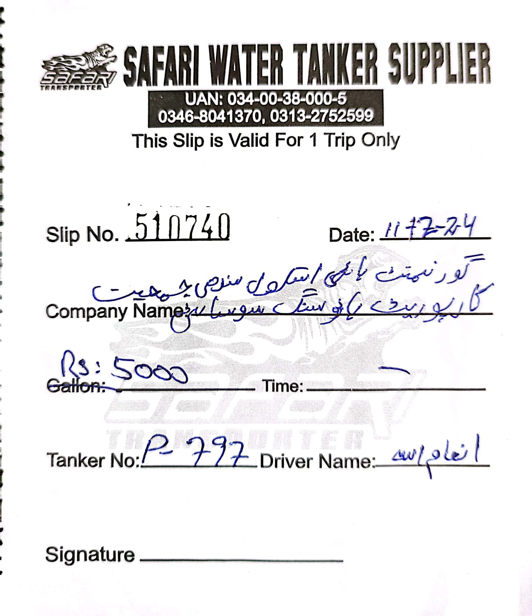

Slip No. 510745 Date: _______________

Company Name: ______________________________
Price: _______________ Time: _______________
Tanker No: ___________ Driver Name: ___________
Signature: __________________
Slip No. 510746 Date: _______________

Company Name: ______________________________
Price: _______________ Time: _______________
Tanker No: ___________ Driver Name: ___________
Signature: __________________



Slip No. 510747 Date: _______________

Company Name: ______________________________
Price: _______________ Time: _______________
Tanker No: ___________ Driver Name: ___________
Signature: __________________
Slip No. 510748 Date: _______________

Company Name: ______________________________
Price: _______________ Time: _______________
Tanker No: ___________ Driver Name: ___________
Signature: __________________

